Interactive Storytelling
http://o.ooli.ca/interactivestorytelling
1. Interactive Stories 1
2. Interactive Fiction and Twine 1
3. Using Twine 2
Getting Started 2
Exercise 7
4. Choice-Based Game Patterns 8
Linear 8
Gauntlet 9
Loops 9
Hub and Spoke 10
Map 11
Exponential Explosion 12
5. Make an Interactive Scene 13
Playtesting 13
6. Make Some Interactive Stories 13
A. Interactive Stories to Read 14
B. Coding Recipes 15
C. Sharing Your Stories 16

Interactive Stories
Interactive stories are different from normal stories. Play the game below called Brevity Quest to try an example of a simple interactive story.
http://o.ooli.ca/BrevityQuest
The game has very little text. It would make for a very dull short story to read. Yet as an interactive story, it is still a compelling experience. Why is that? How does providing choices to a player make a story more interesting and involving?

Interactive Fiction and Twine
We'll explore some of the concepts behind interactive storytelling with a program called Twine. Twine is a tool for making a type of game known as “choice-based interactive fiction.” Interactive fiction stories are sometimes referred to text adventure games.
Twine games are made up of text with choices for players to choose from. Twine games do not need graphics or sound, making them easier to make. Without the distraction of graphics, game makers can focus on the interaction and choices in a game. This makes Twine an ideal tool for practicing making interactive stories.

Using Twine
Twine can be downloaded from this website:
http://twinery.org/
You can also run it in a web browser without downloading anything by going here:
http://twinery.org/2

Getting Started
Once you have Twine running, you can start making a story by clicking on the “+ New” button at the top-left of the screen and then giving a name for your story.

You will then see a screen that looks like this:
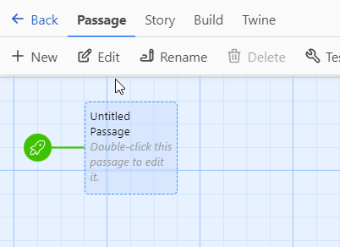
The screen shows a diagram of your interactive story. In Twine, a story is made up of different “passages.”
When playing a Twine game, a passage is a screen of text with some choices. When you make choices, you will be shown a different passage with different text.
In the Twine editor, each passage is shown as a box. The box shows the first few words of text of a passage as well as a title describing the contents of the passage. There are also lines between boxes to show how making a choice moves the game to a different passage.
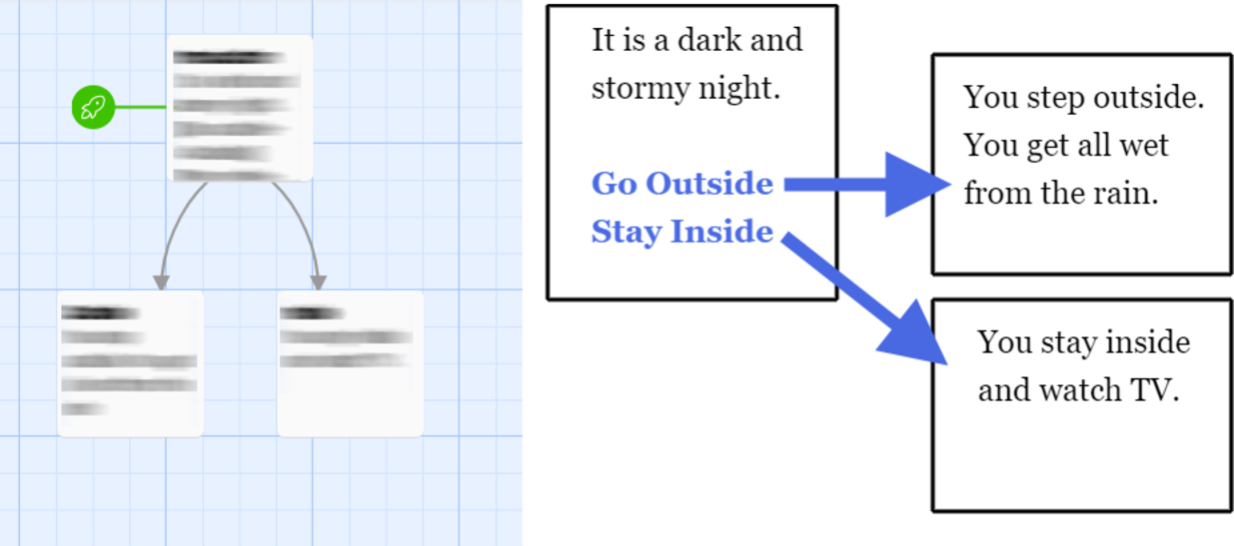
Let's start making a story. Click on one of the passages to select it. Then, at the top of the screen, click on the Edit button to edit it.
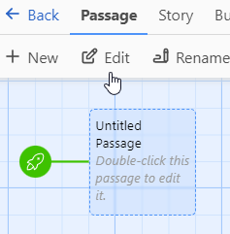
You will then see a window for editing a passage.
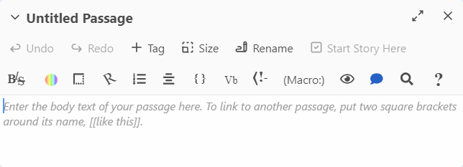
At the top of the window is the title or name of the passage. This title does not appear in the game when you play it. It is used for keeping your passages organized. The main part of the window holds the text of the passage. This text is what is shown to you when you play your game.
Click on the “Rename” button to change the passage title. Set the title to “Introduction”
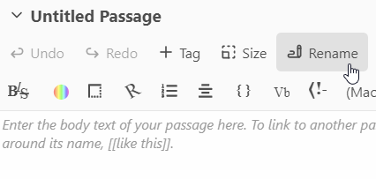
Then, in the main part of the passage window, set the passage contents to
It is a dark and stormy night.
Finally, click on the X in the upper-right of the passage window to close the passage.
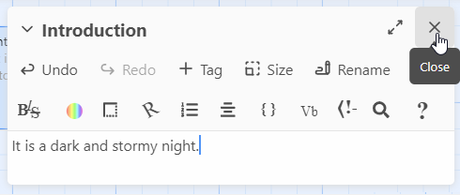
You can then try out your game by first clicking on the “Build” button at the top of the screen to open the Build menu. Then click on the “Play” button.
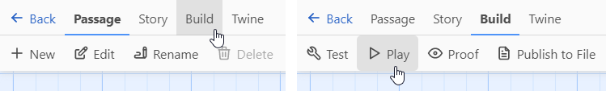
Since the game currently only has a single passage, the game will simply display the text of the passage with nothing for you to do. Close the game and let's add some more passages to the game.
Let's give the player the option of going outside. Click on the “Passage” button at the top of the screen to switch to the Passage menu, then click on the “+New” button to create a new passage. Sometimes, the new passage will end up on top of another passage or in another place where you don't want it. You can drag the passage somewhere else.
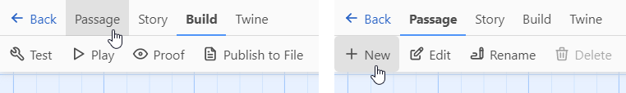
Now select the passage and edit it. Change the name of the passage to “Outside” and set the passage contents to
You step outside. You get all wet from the rain.
Then go and edit the “Introduction” passage. Add this line to the end of the passage:
[[Go outside->Outside]]
Make sure the capitalization of “Outside” is same as the name of the passage you created previously. Also make sure that there are no extra spaces.
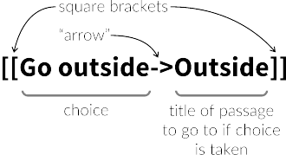

This means that Twine will show the text “Go outside” to the player. If the player clicks it, the game will change to the passage called “Outside.” Play your game and see if it works correctly.
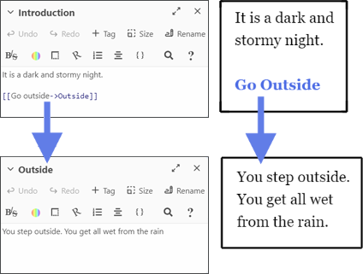
Try modifying the game so that the player has the choice to stay inside instead of going outside.
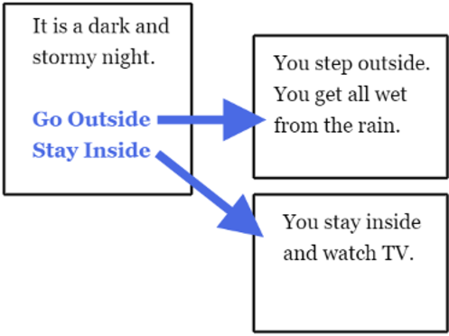

Exercise
Make an interactive story for the conversation shown here:

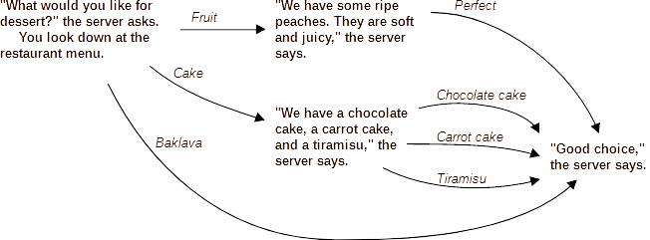

Choice-Based Game Patterns
There are many common patterns that you may encounter when building a choice-based game. These patterns give different experiences to a player. Here are a few such patterns:

Linear
When a game flows in a straight-line with no choices, then it is considered linear. This sort of pattern is not very interactive.
Example:
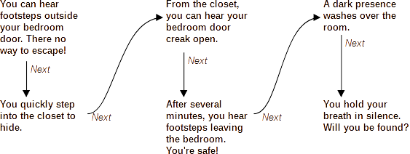
You can also have a story where the player has some choices even if they can't change the major events or plot points of the story. Player choices affect the interpretation and feel of the story.
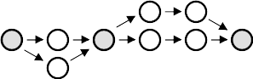
Example:
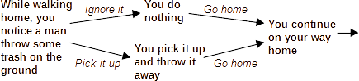

Gauntlet
In this pattern, there is one “correct” path of choices that advances the game. If a player chooses incorrect choices, then the game immediately ends. Games based on this pattern can be very frustrating to play.
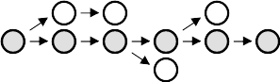
Example:
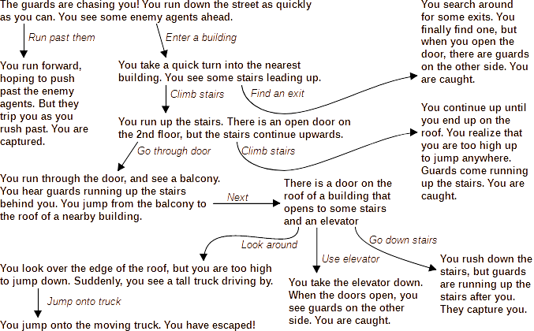

Loops
Having loops or cycles in a game can help extend the length of a game and make it easier for a player to explore an area. Remember to provide a way out of the loop!

Hub and Spoke
In this pattern, there's a central hub that a player repeatedly visits where the player can choose from different options like different adventures or different conversation topics. After exploring these options, the player returns to the hub again where they can explore a different option or exit the hub entirely.
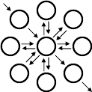
Example:
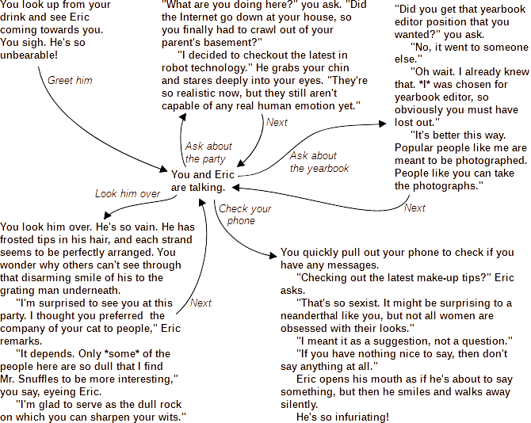

Map
Some games have a structure that directly represents a map of a physical location.
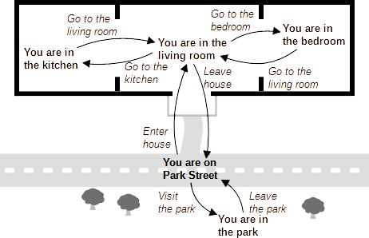

Exponential Explosion
Writers often try to put in as many choices and as many different endings as possible in their interactive stories. Having too many choices causes a problem known as exponential growth. Each time there's a choice in your game, it can double the amount of work you need to do. A game with one choice can have two different endings. A game with two choices can have four different endings. This can quickly grow. A game with ten choices can have over one thousand endings. A game with twenty choices can have over one million different endings.
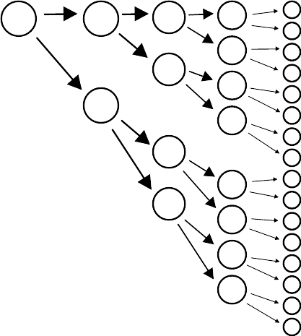
This exponential growth of work is actually a common problem faced by computer scientists. Some computer programs run slowly because they need to do an exponential amount of work to solve difficult problems. Computer scientists have a number of tools for understanding and managing exponential growth. For interactive fiction, the exponential growth can be managed by using a feature called variables and by having different choices lead to the same ending.
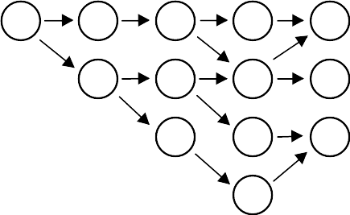

Make an Interactive Scene
Now that you are familiar with how Twine works, why don't you try writing a short interactive scene in Twine? You can make a short conversation or a map to explore or an exciting adventure. One way to start is to take a scene from a normal, non-interactive story, and add some interesting choices to it. You don't need all possible choices. Just like on a multiple-choice quiz, you only need the most likely choices that people will choose.

Playtesting
After you have finished your scene, you should playtest it. During playtesting, you get people to test your game by playing it. In normal fiction, you can often write for yourself, but in interactive fiction, you are always writing for someone else. An interactive story only makes sense if someone is interacting with it. Players change the story with their choices. You must playtest your game to see if the story still makes sense with different combinations of choices.

Make Some Interactive Stories
After you've had some experience making a small scene, try writing a full interactive story. You will find that interactive stories can be better than non-interactive stories at certain things:
Exploration: Interactive stories let readers discover parts of the story at their own pace. Readers can view the same story multiple times with different choices or characters, allowing them to see a story from different perspectives.
Self-Expression and Roleplaying: Readers can shape interactive stories around their own characteristics or preferences. They can choose a character's personality or actions. They can have control over the focus of a story, spending more time with setting, theme, or certain characters depending on their interests.
Challenge: Interactive stories can include a difficulty for the player to overcome. These difficulties can be puzzles that force a player to figure something out to enhance their understanding of the story. These challenges can even be used to teach players a skill.
Complicity: Instead of being passive readers, players of interactive stories can be deeply involved in the plot of a story. The players can be made to feel responsible for what's happening in a story because it results from their choices. Alternately, an author can remove choices to show players what it means to have limited options and help players develop empathy for others in similar situations.
Choice and Moral Decisions: Interactive stories can be used to make players confront difficult choices and to let them see the outcomes of different choices.

Appendix
        - Interactive Stories to Read
Having trouble coming up with ideas for your own interactive stories? Try some of these interactive fiction games for inspiration:
Tangaroa Deep
We know more about space than we do about the ocean. Isn’t it time to start changing that?
http://astriddalmady.com/deep.html

Choice of Dragon
Play as a fire-breathing dragon who sleeps on gold and kidnaps princesses for fun!
https://www.choiceofgames.com/dragon/

Magical Makeover
Parody of Makeover Games (for young adults as some scenes may be disturbing)
http://www.philome.la/Citrushistrix/magical-makeover-v2/play

Hana Feels
Something is bothering Hana. Can you work out what it is? Take the part of four important people in her life and guide their conversations.
http://hanafeels.com/index.html

Secret Agent Cinders
In this game, you play as a revolutionary agent Cinder. Your mission is to infiltrate the Royal Ball, dodge the guards and steal the Secret Military Plans, all before midnight.
http://emilyryan.se/cinder/secret-agent-cinder.html

Thanksgiving
Thanksgiving is a story game about being an anxious student with secrets, meeting your boyfriend's folks for the first time. And being Judged.
https://hannahps.itch.io/thanksgiving
        - Coding Recipes
Below are some recipes for getting different effects in your game:
Italics
To create italics, put your text between * * symbols
*italics text* | italics text
Bold
To make bold text, put your text between two ** ** symbols.
**bold text** | bold text
Headings
To make a title or other heading, put a # symbol at the start of a line. Use two ## symbols to make a subheading.
# Title  ## by me | Title  by me
Back Choice
Sometimes, you want a link for going back to the previous passage. There is a special command for that.
You reach a dead-end.  (link-undo: "Go back") | You reach a dead-end.  Go back
Line Breaks
Sometimes, you want to have different lines of text all combined into a single line or paragraph. You can put a \ symbol at the end of a line to join it with the next line. Alternately, you can put several lines between { and } symbols to combine them all together.
What's your name? \  John  {  Where do you live?  London  } | What's your name? John  Where do you live? London

Here is how to use some of the more advanced features of Twine.
Comments
If you want to put a comment in your code that isn't actually shown in the game, you should put that comment between <!-- and --> symbols.
My name is John. <!-- Note to self: is that the best name? --> | My name is John.
Displaying Another Passage
One passage can display the contents of another passage. This is useful if the same text is repeated in many different passages.
(display: "name of passage")
Variables
You can store data in variables. Variable names begin with a $ dollar sign. You can put numbers, strings, or other types of data in variables. You can print out variables using the print command.
(set: $name to "Alice")  (print: $name) | Alice
If
You can make some text be displayed in only certain situations by using the (if:), (else-if:), and (else:) commands.
(if: $name is "Alice")[This is displayed only for Alice]  (else:)[If you can read this, then you aren't Alice] | This is displayed only for Alice
Only Visit a Passage Once
To display a choice only if you haven't visited a certain passage before, you can use this recipe
(if: not ("Passage" is in (history:)))[ [[Passage]]] | Passage

        - Sharing Your Stories
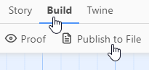
When you finish making an interactive story, you can share it with others. With your story open, simply go to the “Build” menu, and click on “Publish to File.” Other people can open the published file in a web browser to play your game. You can send the file to others by e-mail or put it up on a website. It's also possible to edit other people's published files by importing them back into Twine.

